TASK -1

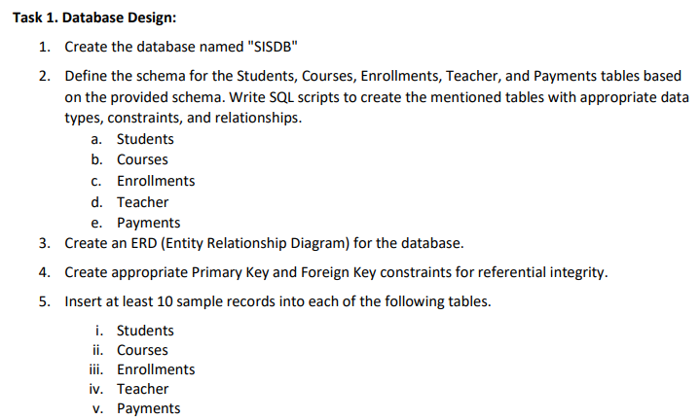mysql> create database sisdb;

Database created

mysql> use sisdb;

Database changed

mysql> create table students (

-> student_id int primary key auto_increment,

-> first_name varchar(50),

-> last_name varchar(50),

-> date_of_birth date,

-> email varchar(100),

-> phone_number varchar(15)

-> );

Query OK, 0 rows affected (0.02 sec)

mysql> create table teacher (

-> teacher_id int primary key auto_increment,

-> first_name varchar(50),

-> last_name varchar(50),

-> email varchar(100)

-> );

Query OK, 0 rows affected (0.02 sec)

mysql> create table courses (

-> course_id int primary key auto_increment,

-> course_name varchar(100),

-> credits int,

-> teacher_id int,

-> foreign key (teacher_id) references teacher(teacher_id)

-> );

Query OK, 0 rows affected (0.04 sec)

mysql> create table enrollments (

-> enrollment_id int primary key auto_increment,

-> student_id int,

-> course_id int,

-> enrollment_date date,

-> foreign key (student_id) references students(student_id),

-> foreign key (course_id) references courses(course_id)

-> );

Query OK, 0 rows affected (0.06 sec)

mysql> create table payments (

-> payment_id int primary key auto_increment,

-> student_id int,

-> amount int,

-> payment_date date,

-> foreign key (student_id) references students(student_id)

-> );

Query OK, 0 rows affected (0.06 sec)

mysql> INSERT INTO Students (first_name, last_name, date_of_birth, email, phone_number)

-> VALUES

-> ('Amit', 'Kumar', '1997-06-10', 'amit.kumar@example.com', '9876543210'),

-> ('Riya', 'Sharma', '1998-08-23', 'riya.sharma@example.com', '9876543211'),

-> ('Karan', 'Singh', '1996-03-12', 'karan.singh@example.com', '9876543212'),

-> ('Priya', 'Verma', '1995-11-17', 'priya.verma@example.com', '9876543213'),

-> ('Rahul', 'Joshi', '1999-01-08', 'rahul.joshi@example.com', '9876543214'),

-> ('Sneha', 'Patel', '1997-07-20', 'sneha.patel@example.com', '9876543215'),

-> ('Arjun', 'Nair', '1998-05-05', 'arjun.nair@example.com', '9876543216'),

-> ('Anita', 'Rao', '1996-02-22', 'anita.rao@example.com', '9876543217'),

-> ('Vikram', 'Gupta', '1997-12-13', 'vikram.gupta@example.com', '9876543218'),

-> ('Pooja', 'Mehta', '1999-10-31', 'pooja.mehta@example.com', '9876543219');

Query OK, 10 rows affected (0.01 sec)

Records: 10 Duplicates: 0 Warnings: 0

mysql> Select * from Students;

+------------+------------+-----------+---------------+--------------------------+--------------+

| student_id | first_name | last_name | date_of_birth | email | phone_number |

+------------+------------+-----------+---------------+--------------------------+--------------+

| 1 | Amit | Kumar | 1997-06-10 | amit.kumar@example.com | 9876543210 |

| 2 | Riya | Sharma | 1998-08-23 | riya.sharma@example.com | 9876543211 |

| 3 | Karan | Singh | 1996-03-12 | karan.singh@example.com | 9876543212 |

| 4 | Priya | Verma | 1995-11-17 | priya.verma@example.com | 9876543213 |

| 5 | Rahul | Joshi | 1999-01-08 | rahul.joshi@example.com | 9876543214 |

| 6 | Sneha | Patel | 1997-07-20 |

sneha.patel@example.com | 9876543215 |

| 7 | Arjun | Nair | 1998-05-05 | arjun.nair@example.com | 9876543216 |

| 8 | Anita | Rao | 1996-02-22 | anita.rao@example.com | 9876543217 |

| 9 | Vikram | Gupta | 1997-12-13 | vikram.gupta@example.com | 9876543218 |

| 10 | Pooja | Mehta | 1999-10-31 | pooja.mehta@example.com | 9876543219 |

+------------+------------+-----------+---------------+--------------------------+--------------+

10 rows in set (0.00 sec)

mysql> INSERT INTO Teacher (first_name, last_name, email)

-> VALUES

-> ('Anil', 'Yadav', 'anil.yadav@example.com'),

-> ('Deepa', 'Iyer', 'deepa.iyer@example.com'),

-> ('Rajesh', 'Bhatt', 'rajesh.bhatt@example.com'),

-> ('Sonal', 'Mishra', 'sonal.mishra@example.com'),

-> ('Ravi', 'Kapoor', 'ravi.kapoor@example.com');

Query OK, 5 rows affected (0.01 sec)

Records: 5 Duplicates: 0 Warnings: 0

mysql> Select * from Teacher;

+------------+------------+-----------+--------------------------+

| teacher_id | first_name | last_name | email

|

+------------+------------+-----------+--------------------------+

| 1 | Anil | Yadav | anil.yadav@example.com |

| 2 | Deepa | Iyer | deepa.iyer@example.com |

| 3 | Rajesh | Bhatt | rajesh.bhatt@example.com |

| 4 | Sonal | Mishra | sonal.mishra@example.com |

| 5 | Ravi | Kapoor | ravi.kapoor@example.com |

+------------+------------+-----------+--------------------------+

5 rows in set (0.00 sec)

mysql> INSERT INTO Courses (course_name, credits, teacher_id)

-> VALUES

-> ('Mathematics 101', 3, 1),

-> ('Physics 101', 4, 2),

-> ('Computer Science 101', 5, 3),

-> ('Chemistry 101', 3, 4),

-> ('Biology 101', 3, 5);

Query OK, 5 rows affected (0.01 sec)

Records: 5 Duplicates: 0 Warnings: 0

mysql> Select * from Courses;

+-----------+----------------------+---------+------------+

| course_id | course_name | credits | teacher_id |

+-----------+----------------------+---------+------------+

| 1 | Mathematics 101 | 3 |

1 |

| 2 | Physics 101 | 4 |

2 |

| 3 | Computer Science 101 | 5 |

3 |

| 4 | Chemistry 101 | 3 |

4 |

| 5 | Biology 101 | 3 |

5 |

+-----------+----------------------+---------+------------+

5 rows in set (0.00 sec)

mysql> INSERT INTO Enrollments (student_id, course_id, enrollment_date)

-> VALUES

-> (1, 1, CURDATE()),

-> (2, 2, CURDATE()),

-> (3, 3, CURDATE()),

-> (4, 4, CURDATE()),

-> (5, 5, CURDATE());

Query OK, 5 rows affected (0.01 sec)

Records: 5 Duplicates: 0 Warnings: 0

mysql> Select * from Enrollments;

+---------------+------------+-----------+-----------------+

| enrollment_id | student_id | course_id | enrollment_date |

+---------------+------------+-----------+-----------------+

| 1 | 1 | 1 | 2024-09-30 |

| 2 | 2 | 2 | 2024-09-30 |

| 3 | 3 | 3 | 2024-09-30 |

| 4 | 4 | 4 | 2024-09-30 |

| 5 | 5 | 5 | 2024-09-30 |

+---------------+------------+-----------+-----------------+

5 rows in set (0.00 sec)

mysql> INSERT INTO Enrollments (student_id, course_id, enrollment_date)

-> VALUES

-> (6, 1, CURDATE()),

-> (6, 2, CURDATE()),

-> (7, 3, CURDATE()),

-> (8, 4, CURDATE()),

-> (9, 5, CURDATE()),

-> (10, 3, CURDATE()),

-> (10, 1, CURDATE());

Query OK, 7 rows affected (0.01 sec)

Records: 7 Duplicates: 0 Warnings: 0

mysql> select * from Enrollments;

+---------------+------------+-----------+-----------------+

| enrollment_id | student_id | course_id | enrollment_date |

+---------------+------------+-----------+-----------------+

| 1 | 1 | 1 | 2024-09-30 |

| 2 | 2 | 2 | 2024-09-30 |

| 3 | 3 | 3 | 2024-09-30 |

| 4 | 4 | 4 | 2024-09-30 |

| 5 | 5 | 5 | 2024-09-30 |

| 6 | 6 | 1 | 2024-09-30 |

| 7 | 6 | 2 | 2024-09-30 |

| 8 | 7 | 3 | 2024-09-30 |

| 9 | 8 | 4 | 2024-09-30 |

| 10 | 9 | 5 | 2024-09-30 |

| 11 | 10 | 3 | 2024-09-30 |

| 12 | 10 | 1 | 2024-09-30 |

+---------------+------------+-----------+-----------------+

12 rows in set (0.00 sec)

mysql> INSERT INTO Payments (student_id, amount, payment_date)

-> VALUES

-> (1, 300.00, CURDATE()),

-> (2, 400.00, CURDATE()),

-> (3, 500.00, CURDATE()),

-> (4, 600.00, CURDATE()),

-> (5, 700.00, CURDATE()),

-> (6, 800.00, CURDATE()),

-> (7, 900.00, CURDATE()),

-> (8, 1000.00, CURDATE()),

-> (9, 1000.00, CURDATE()),

-> (10, 1000.00, CURDATE());

Query OK, 10 rows affected (0.01 sec)

Records: 10 Duplicates: 0 Warnings: 0

mysql> select * from Payments;

+------------+------------+--------+--------------+

| payment_id | student_id | amount | payment_date |

+------------+------------+--------+--------------+

| 1 | 1 | 300 | 2024-09-30 |

| 2 | 2 | 400 | 2024-09-30 |

| 3 | 3 | 500 | 2024-09-30 |

| 4 | 4 | 600 | 2024-09-30 |

| 5 | 5 | 700 | 2024-09-30 |

| 6 | 6 | 800 | 2024-09-30 |

| 7 | 7 | 900 | 2024-09-30 |

| 8 | 8 | 1000 | 2024-09-30 |

| 9 | 9 | 1000 | 2024-09-30 |

| 10 | 10 | 1000 | 2024-09-30 |

+------------+------------+--------+--------------+

10 rows in set (0.00 sec)

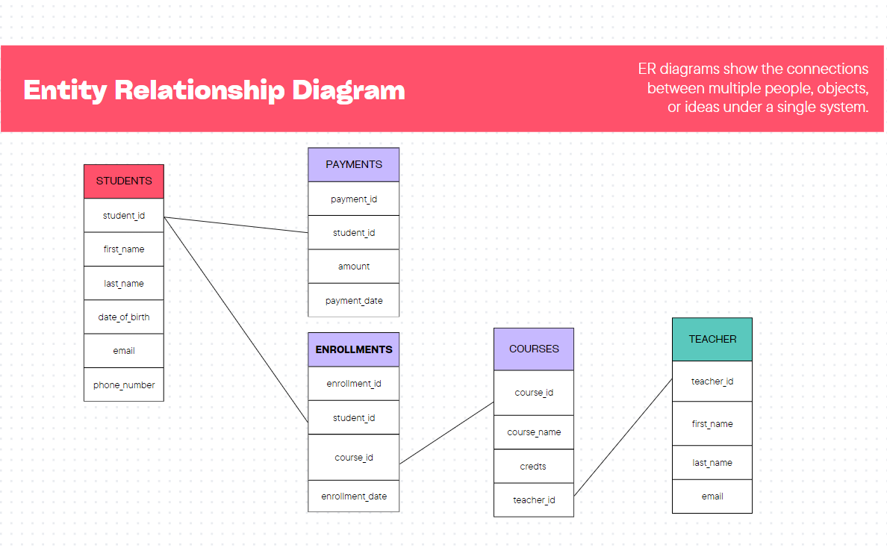

TASK - 2



1. mysql> insert into students (first_name, last_name, date_of_birth, email, phone_number)

-> values ('John', 'Doe', '1995-08-15', 'john.doe@example.com', '1234567890');

Query OK, 1 row affected (0.00 sec)

mysql> select * from students;

+------------+------------+-----------+---------------+--------------------------+--------------+

| student_id | first_name | last_name | date_of_birth | email

| phone_number |

+------------+------------+-----------+---------------+--------------------------+--------------+

| 1 | Amit | Kumar | 1997-06-10 | amit.kumar@example.com | 9876543210 |

| 2 | Riya | Sharma | 1998-08-23 | riya.sharma@example.com | 9876543211 |

| 3 | Karan | Singh | 1996-03-12 | karan.singh@example.com | 9876543212 |

| 4 | Priya | Verma | 1995-11-17 | priya.verma@example.com | 9876543213 |

| 5 | Rahul | Joshi | 1999-01-08 | rahul.joshi@example.com | 9876543214 |

| 6 | Sneha | Patel | 1997-07-20 | sneha.patel@example.com | 9876543215 |

| 7 | Arjun | Nair | 1998-05-05 | arjun.nair@example.com | 9876543216 |

| 8 | Anita | Rao | 1996-02-22 | anita.rao@example.com | 9876543217 |

| 9 | Vikram | Gupta | 1997-12-13 | vikram.gupta@example.com | 9876543218 |

| 10 | Pooja | Mehta | 1999-10-31 | pooja.mehta@example.com | 9876543219 |

| 11 | John | Doe | 1995-08-15 | john.doe@example.com | 1234567890 |

+------------+------------+-----------+---------------+--------------------------+--------------+

11 rows in set (0.00 sec)

2. mysql> insert into enrollments (student_id, course_id, enrollment_date)

-> values (1, 2, curdate());

Query OK, 1 row affected (0.00 sec)

mysql> select * from enrollments;

+---------------+------------+-----------+-----------------+

| enrollment_id | student_id | course_id | enrollment_date |

+---------------+------------+-----------+-----------------+

| 1 | 1 | 1 | 2024-09-30 |

| 2 | 2 | 2 | 2024-09-30 |

| 3 | 3 | 3 | 2024-09-30 |

| 4 | 4 | 4 | 2024-09-30 |

| 5 | 5 | 5 | 2024-09-30 |

| 6 | 6 | 1 | 2024-09-30 |

| 7 | 6 | 2 | 2024-09-30 |

| 8 | 7 | 3 | 2024-09-30 |

| 9 | 8 | 4 | 2024-09-30 |

| 10 | 9 | 5 | 2024-09-30 |

| 11 | 10 | 3 | 2024-09-30 |

| 12 | 10 | 1 | 2024-09-30 |

| 13 | 1 | 2 | 2024-09-30 |

+---------------+------------+-----------+-----------------+

13 rows in set (0.00 sec)

3. mysql> update teacher

-> set email = 'new.email@example.com'

-> where teacher_id = 5;

Query OK, 1 row affected (0.01 sec)

Rows matched: 1 Changed: 1 Warnings: 0

mysql> select * from teacher;

+------------+------------+-----------+--------------------------+

| teacher_id | first_name | last_name | email |

+------------+------------+-----------+--------------------------+

| 1 | Anil | Yadav | anil.yadav@example.com |

| 2 | Deepa | Iyer | deepa.iyer@example.com |

| 3 | Rajesh | Bhatt | rajesh.bhatt@example.com |

| 4 | Sonal | Mishra | sonal.mishra@example.com |

| 5 | Ravi | Kapoor | new.email@example.com |

+------------+------------+-----------+--------------------------+

5 rows in set (0.00 sec)

4.mysql> delete from enrollments

-> where student_id = 1

-> and course_id = 1;

Query OK, 1 row affected (0.00 sec)

mysql> select * from enrollments;

+---------------+------------+-----------+-----------------+

| enrollment_id | student_id | course_id | enrollment_date |

+---------------+------------+-----------+-----------------+

| 2 | 2 | 2 | 2024-09-30 |

| 3 | 3 | 3 | 2024-09-30 |

| 4 | 4 | 4 | 2024-09-30 |

| 5 | 5 | 5 | 2024-09-30 |

| 6 | 6 | 1 | 2024-09-30 |

| 7 | 6 | 2 | 2024-09-30 |

| 8 | 7 | 3 | 2024-09-30 |

| 9 | 8 | 4 | 2024-09-30 |

| 10 | 9 | 5 | 2024-09-30 |

| 11 | 10 | 3 | 2024-09-30 |

| 12 | 10 | 1 | 2024-09-30 |

| 13 | 1 | 2 | 2024-09-30 |

+---------------+------------+-----------+-----------------+

12 rows in set (0.00 sec)

5. mysql> update courses

-> set teacher_id = 3

-> where course_id = 1;

Query OK, 1 row affected (0.00 sec)

Rows matched: 1 Changed: 1 Warnings: 0

mysql> select * from courses;

+-----------+----------------------+---------+------------+

| course_id | course_name | credits | teacher_id |

+-----------+----------------------+---------+------------+

| 1 | Mathematics 101 | 3 | 3 |

| 2 | Physics 101 | 4 | 2 |

| 3 | Computer Science 101 | 5 | 3 |

| 4 | Chemistry 101 | 3 | 4 |

| 5 | Biology 101 | 3 | 5 |

+-----------+----------------------+---------+------------+

5 rows in set (0.00 sec)

6.mysql> delete from enrollments

-> where student_id = 1;

Query OK, 1 row affected (0.00 sec)

mysql> select * from enrollments;

+---------------+------------+-----------+-----------------+

| enrollment_id | student_id | course_id | enrollment_date |

+---------------+------------+-----------+-----------------+

| 2 | 2 | 2 | 2024-09-30 |

| 3 | 3 | 3 | 2024-09-30 |

| 4 | 4 | 4 | 2024-09-30 |

| 5 | 5 | 5 | 2024-09-30 |

| 6 | 6 | 1 | 2024-09-30 |

| 7 | 6 | 2 | 2024-09-30 |

| 8 | 7 | 3 | 2024-09-30 |

| 9 | 8 | 4 | 2024-09-30 |

| 10 | 9 | 5 | 2024-09-30 |

| 11 | 10 | 3 | 2024-09-30 |

| 12 | 10 | 1 | 2024-09-30 |

+---------------+------------+-----------+-----------------+

11 rows in set (0.00 sec)

7 .mysql> update payments

-> set amount = 500.00

-> where payment_id = 10;

Query OK, 1 row affected (0.00 sec)

Rows matched: 1 Changed: 1 Warnings: 0

mysql> select * from payments;

+------------+------------+--------+--------------+

| payment_id | student_id | amount | payment_date |

+------------+------------+--------+--------------+

| 1 | 1 | 300 | 2024-09-30 |

| 2 | 2 | 400 | 2024-09-30 |

| 3 | 3 | 500 | 2024-09-30 |

| 4 | 4 | 600 | 2024-09-30 |

| 5 | 5 | 700 | 2024-09-30 |

| 6 | 6 | 800 | 2024-09-30 |

| 7 | 7 | 900 | 2024-09-30 |

| 8 | 8 | 1000 | 2024-09-30 |

| 9 | 9 | 1000 | 2024-09-30 |

| 10 | 10 | 500 | 2024-09-30 |

+------------+------------+--------+--------------+

10 rows in set (0.00 sec)

TASK - 3



1.mysql> select s.first_name, s.last_name, sum(p.amount) as total_payments

-> from students s

-> join payments p on s.student_id = p.student_id

-> where s.student_id = '7'

-> group by s.student_id;

+------------+-----------+----------------+

| first_name | last_name | total_payments |

+------------+-----------+----------------+

| Arjun | Nair | 900 |

+------------+-----------+----------------+

1 row in set (0.01 sec)

2. mysql> select c.course_name, count(e.student_id) as student_count

-> from courses c

-> left join enrollments e on c.course_id = e.course_id

-> group by c.course_id;

+----------------------+---------------+

| course_name | student_count |

+----------------------+---------------+

| Mathematics 101 | 2 |

| Physics 101 | 2 |

| Computer Science 101 | 3 |

| Chemistry 101 | 2 |

| Biology 101 | 2 |

+----------------------+---------------+

5 rows in set (0.00 sec)

3. mysql> select s.first_name, s.last_name

-> from students s

-> left join enrollments e on s.student_id = e.student_id

-> where e.student_id is null;

+------------+-----------+

| first_name | last_name |

+------------+-----------+

| Amit | Kumar |

| John | Doe |

+------------+-----------+

2 rows in set (0.00 sec)

4.mysql> select s.first_name, s.last_name, c.course_name

-> from students s

-> join enrollments e on s.student_id = e.student_id

-> join courses c on e.course_id = c.course_id;

+------------+-----------+----------------------+

| first_name | last_name | course_name |

+------------+-----------+----------------------+

| Sneha | Patel | Mathematics 101 |

| Pooja | Mehta | Mathematics 101 |

| Riya | Sharma | Physics 101 |

| Sneha | Patel | Physics 101 |

| Karan | Singh | Computer Science 101 |

| Arjun | Nair | Computer Science 101 |

| Pooja | Mehta | Computer Science 101 |

| Priya | Verma | Chemistry 101 |

| Anita | Rao | Chemistry 101 |

| Rahul | Joshi | Biology 101 |

| Vikram | Gupta | Biology 101 |

+------------+-----------+----------------------+

11 rows in set (0.00 sec)

5. mysql> select t.first_name, t.last_name, c.course_name

-> from teacher t

-> join courses c on t.teacher_id = c.teacher_id;

+------------+-----------+----------------------+

| first_name | last_name | course_name |

+------------+-----------+----------------------+

| Deepa | Iyer | Physics 101 |

| Rajesh | Bhatt | Mathematics 101 |

| Rajesh | Bhatt | Computer Science 101 |

| Sonal | Mishra | Chemistry 101 |

| Ravi | Kapoor | Biology 101 |

+------------+-----------+----------------------+

5 rows in set (0.00 sec)

6.

mysql> select s.first_name, s.last_name, e.enrollment_date

-> from students s

-> join enrollments e on s.student_id = e.student_id

-> join courses c on e.course_id = c.course_id

-> where c.course_id = 2;

+------------+-----------+-----------------+

| first_name | last_name | enrollment_date |

+------------+-----------+-----------------+

| Riya | Sharma | 2024-09-30 |

| Sneha | Patel | 2024-09-30 |

+------------+-----------+-----------------+

2 rows in set (0.00 sec)

7.mysql> select s.first_name, s.last_name

-> from students s

-> left join payments p on s.student_id = p.student_id

-> where p.student_id is null;

+------------+-----------+

| first_name | last_name |

+------------+-----------+

| John | Doe |

+------------+-----------+

1 row in set (0.00 sec)

8.mysql> select c.course_name

-> from courses c

-> left join enrollments e on c.course_id = e.course_id

-> where e.course_id is null;

Empty set (0.00 sec)

9.mysql> select s.first_name, s.last_name, count(e.course_id) as course_count

-> from students s

-> join enrollments e on s.student_id = e.student_id

-> group by s.student_id

-> having count(e.course_id) > 1;

+------------+-----------+--------------+

| first_name | last_name | course_count |

+------------+-----------+--------------+

| Sneha | Patel | 2 |

| Pooja | Mehta | 2 |

+------------+-----------+--------------+

2 rows in set (0.00 sec)

10. mysql> select t.first_name, t.last_name

-> from teacher t

-> left join courses c on t.teacher_id = c.teacher_id

-> where c.course_id is null;

+------------+-----------+

| first_name | last_name |

+------------+-----------+

| Anil | Yadav |

+------------+-----------+

1 row in set (0.00 sec)

TASK – 4

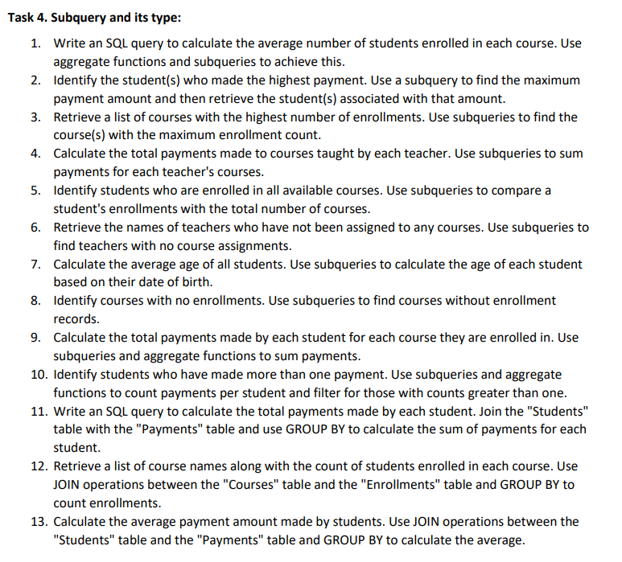

1 .

mysql> select avg(student_count) as avg_students

-> from (

-> select course_id, count(student_id) as student_count

-> from enrollments

-> group by course_id

-> ) as course_enrollments;

+--------------+

| avg_students |

+--------------+

| 2.2000 |

+--------------+

1 row in set (0.02 sec)2.

mysql> select student_id, amount

-> from payments

-> where amount = (select max(amount) from payments);

+------------+--------+

| student_id | amount |

+------------+--------+

| 8 | 1000 |

| 9 | 1000 |

+------------+--------+

2 rows in set (0.01 sec)

3.

mysql> select course_id

-> from enrollments

-> group by course_id

-> having count(student_id) = (

-> select max(enrollment_count)

-> from (

-> select course_id, count(student_id) as enrollment_count

-> from enrollments

-> group by course_id

-> ) as course_counts

-> );

+-----------+

| course_id |

+-----------+

| 3 |

+-----------+

1 row in set (0.00 sec)

4.

mysql> select c.teacher_id, sum(p.amount) as total_payments

-> from courses c

-> join enrollments e on c.course_id = e.course_id

-> join payments p on e.student_id = p.student_id

-> group by c.teacher_id;

+------------+----------------+

| teacher_id | total_payments |

+------------+----------------+

| 2 | 1200 |

| 3 | 3200 |

| 4 | 1600 |

| 5 | 1700 |

+------------+----------------+

4 rows in set (0.00 sec)

5. mysql> select student_id

-> from enrollments

-> group by student_id

-> having count(course_id) = (select count(course_id) from courses);

Empty set (0.02 sec)

6. mysql> select teacher_id

-> from teacher

-> where teacher_id not in (select distinct teacher_id from courses);

+------------+

| teacher_id |

+------------+

| 1 |

+------------+

1 row in set (0.00 sec)

7.

mysql> select avg(datediff(curdate(), date_of_birth) / 365) as average_age

-> from students;

+-------------+

| average_age |

+-------------+

| 27.25653798 |

+-------------+

1 row in set (0.01 sec)

8. mysql> select course_id

-> from courses

-> where course_id not in (select distinct course_id from enrollments);

Empty set (0.00 sec)

9.

mysql> select e.student_id, e.course_id, sum(p.amount) as total_payments

-> from enrollments e

-> join payments p on e.student_id = p.student_id

-> group by e.student_id, e.course_id;

+------------+-----------+----------------+

| student_id | course_id | total_payments |

+------------+-----------+----------------+

| 2 | 2 | 400 |

| 3 | 3 | 500 |

| 4 | 4 | 600 |

| 5 | 5 | 700 |

| 6 | 1 | 800 |

| 6 | 2 | 800 |

| 7 | 3 | 900 |

| 8 | 4 | 1000 |

| 9 | 5 | 1000 |

| 10 | 3 | 500 |

| 10 | 1 | 500 |

+------------+-----------+----------------+

11 rows in set (0.00 sec)

10.

mysql> select student_id

-> from payments

-> group by student_id

-> having count(payment_id) > 1;

Empty set (0.00 sec)

11.

mysql> select s.student_id, sum(p.amount) as total_payment

-> from students s

-> join payments p on s.student_id = p.student_id

-> group by s.student_id;

+------------+---------------+

| student_id | total_payment |

+------------+---------------+

| 1 | 300 |

| 2 | 400 |

| 3 | 500 |

| 4 | 600 |

| 5 | 700 |

| 6 | 800 |

| 7 | 900 |

| 8 | 1000 |

| 9 | 1000 |

| 10 | 500 |

+------------+---------------+

10 rows in set (0.00 sec)

12.

mysql> select c.course_name, count(e.student_id) as student_count

-> from courses c

-> left join enrollments e on c.course_id = e.course_id

-> group by c.course_id;

+----------------------+---------------+

| course_name | student_count |

+----------------------+---------------+

| Mathematics 101 | 2 |

| Physics 101 | 2 |

| Computer Science 101 | 3 |

| Chemistry 101 | 2 |

| Biology 101 | 2 |

+----------------------+---------------+

5 rows in set (0.00 sec)

13.

mysql> select avg(p.amount) as average_payment

-> from students s

-> join payments p on s.student_id = p.student_id;

+-----------------+

| average_payment |

+-----------------+

| 670.0000 |

+-----------------+

1 row in set (0.00 sec)